**CSS Variables**

The way css variables work is that you declare them on some sort of element or in our case on root

So we will set variables like this

<style>

:root {

--base: #ffc600;

--spacing: 10**px**;

--blur: 10**px**;

So we have defined these variables and now we can use them

img {

padding: var(--spacing);

}

img {

padding: var(--spacing);

background: var(--base);

filter: blur(var(--blur));

}

Now we want to work with the JS of class highlight .hl

.hl {

color: var(--base);

}

So if we change the base everything from hl will change

Now we need to connect with JS toggles to update the css

const inputs **=** **document**.querySelectorAll('.controls input');

it you run this in the console (by copy/paste the document.querySelectorAlll its not an array

it’s a node list

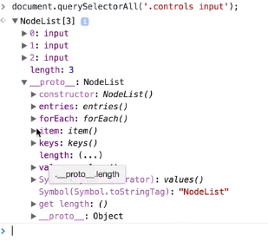

This is the object you get from a Node list.

An array would look like this with much more information in the object

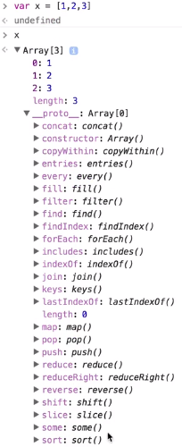

But we are going to use the For Each method that is now available in the node list.

So we are going to create our function called handle update.

function handleUpdate() {

**console**.log(this.**value**);

}

And then listen for a change event for each of the inputs

inputs.forEach(input => input.addEventListener('change', handleUpdate));

so we are going to loop over the inputs(forEach) and use the function symbol => and listen for the change event and when that is call we are going to call handle update

now when we open up the console we can see the value being displayed when you move and release the toggle in the displayed html

we can additionally use the movemouse version to view those values

inputs.forEach(input => input.addEventListener('mousemove', handleUpdate));

Next we are going to want to attach the properties this.value to this.name but when we do we need to be able to apply the suffix because 10px will only register as 10. The color wont need the suffix so we will need to put an execution so when it executes there will not be a undefined and register in null and potentially break

const suffix **=** this.dataset.sizing **||** '';

finally, we want to set the property of name space or blur

**document**.**documentElement**.**style**.setProperty(`--${this.**name**}`, this.**value** **+** suffix);

using SE6 to plop the variable name in and set it to this.value and add the suffix at the end so px will register in 10px.